**The Basic Color Theory**

**Primary Colors:** Red, yellow, blue

**Secondary Colors:** Red+yellow =Orange, Yellow+Blue=Green, Blue+Red=Violet

**Tertiory Colors:** Orange+yellow=Yellow –orange,

Orange+Red=Red-Orange

Green+Yellow=Yellow-Green

Green+Blue=Blue-Green

Violet+Blue=Blue-Violet

Violet+red=Red-Violet

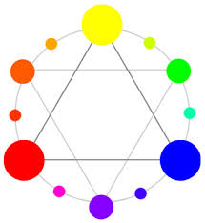

**How to mix black:** The combination of three primary colors will yield black.

Gray is a gentle, pleasing color that is easy on the eye.However,when used by itself “gray” may seem dull.It is influenced by the color that surrounds it.But when used with a semi-neutral or pure-hue color,”gray” comes to life.

**How to mix neutral-gray :**

1. From the tube –payne’s gray,neutral tint,lamp black tint it either with water or white
2. From the complement colors of each color-
   1. Cadmium Yellow Pale +ultramarine blue
   2. Burnt sienna + ultramarine blue
   3. Cadmium yellow medium+ultramarine violet
   4. Naples yellow + ultramarine violet **or** naples yellow +ultramarine blue
   5. Permanent orange +ultramarine blue
   6. Cobalt violet +emerald green
   7. Permanent orange +Cobalt blue
   8. Raw sienna +ultramarine blue
   9. Burnt umber +cobalt blue
   10. Sepia +cerulean blue
   11. Prussian blue +alizarin crimson +winsor green
   12. Prussian blue +burnt sienna +alizarin crimson

**The Language of Color**

The Properties of color (The four major terms you have to learn in watercolor class)

**Hue**

Hue and color are general terms and can be used interchangeably.

Hue is color in its purest form.The colors of the colorwheel are hues.

All of the colors we can perceive are produced by the mixing of certain basis colors-Red,yellow,blue

**Value**

Value is the lightness or darkness of a color.Lightened values are called”tints”

Darkened values are called”shades”,

and medium values are called

“midtones”.

Key-dominant value or color relationships,such high key(light ),low key(dark)and full contrast (full range from light to dark

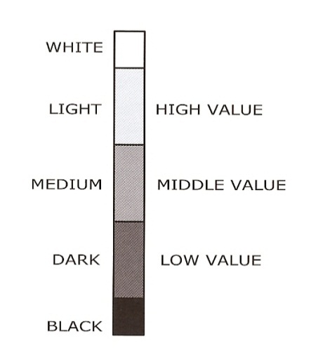

**Intensity**

Intensity also called saturation

chroma, purity, strength, dullness and other term-refers to the amount of black, white or gray mixed with a hue.

[](http://upload.wikimedia.org/wikipedia/en/f/f0/Saturationdemo.png)Pure red is highly saturated or high intensity; maroon has black added(and includes less red);pink may have varying amounts of white added; a dusty rose has varying amounts and/or values of gray added

Adding black or its complementary color creates a”shade”

Adding white or more water creates a “tint”

Adding any value of gray creates a “tone”

**Temperature**

Temperature is the relative warmth or coolness of a color.yellow

Red,orange associated with the warmth of fire and sun.

Blue,green and

Violet connect in the mind’s eye with coolness of sea,sky and foliage.

